|  |  |
| --- | --- |
| **AP Computer Science** | **GraphicsLab03 Java Assignment** |
| **The Random Graphics Program** | **70, 80, 90, 100 & 110 Point Versions** |
| **Assignment Purpose:**  The purpose of this program is to demonstrate knowledge of using constructing objects with the **new** operator and use object methods. | |

For this lab assignment you are provided with a grid of two rows by two columns. Each cell in the grid needs some graphics object to be drawn. It will be necessary to construct objects of the **Random**, **Color** and **Polygon** classes to complete this assignment. The use of the grid is intentional. For three cells you will need to display random graphics objects that must stay within the boundaries of the cell. This becomes a test of your knowledge about generating random values in the proper range. You will not get credit if the objects are drawn outside the cell boundaries.

|  |  |
| --- | --- |
| **GraphicsLab03st Student Version** | **Do not copy this file, which is provided** |
| **// GraphicsLab03st.java**  **// Student Version**  **import java.awt.*;**  **import java.applet.*;**  **import java.util.*;**    **public class GraphicsLab03st extends Applet**  **{**  **public void paint(Graphics g)**  **{**  **// Draw Grid**  **g.drawRect(10,10,780,580);**  **g.drawLine(400,10,400,590);**  **g.drawLine(10,300,790,300);**    **Random rnd = new Random(1234);**    **// Draw Random Lines**      **// Draw Random Squares**    **// Draw Random Circles**    **// Draw 3-D Box**  **}**  **}** | |

**Current Output of GraphicsLab03st.java**

At the beginning, the output is a simple 2 by 2 grid.

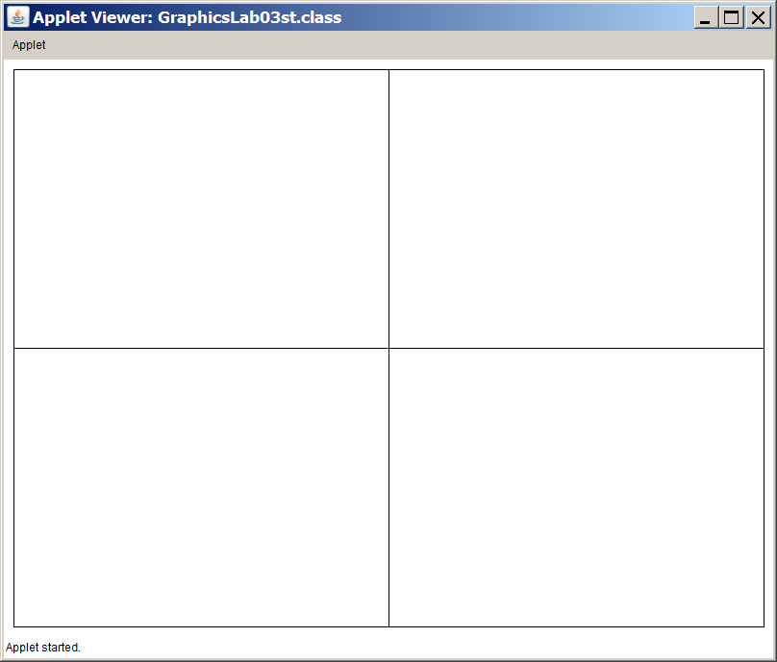

**70, 80, 90 & 100 Point Versions**

The 70-point version displays one of the cells on the next page.

The 80-point version displays two.

The 90-point version displays three.

The 100-point version displays all four.

The cell with lines displays 100 random lines.

Both ends of the line have random x and y coordinate locations.

The lines are also drawn in random colors.

The cell with squares displays 100 random squares.

The squares need to be drawn at random locations within the cell, and be entirely inside the cell.

The squares have a height and width of 50 pixels.

The squares are also drawn in random colors.

The cell with circles displays 100 random circles.

The circles need to be drawn at random locations within the cell, and be entirely inside the cell.

The circles have a random diameter which ranges from 0 to 200 pixels.

The circles are also drawn in random colors.

The random colors used for the first 3 cells are created by having 3 random values from 0 to 255 which represent the red, green, and blue values for the random color.

The cell with the box uses nothing random.

It uses Polygons and the defined colors of red, green, yellow and blue.

**100 Point Version Output**

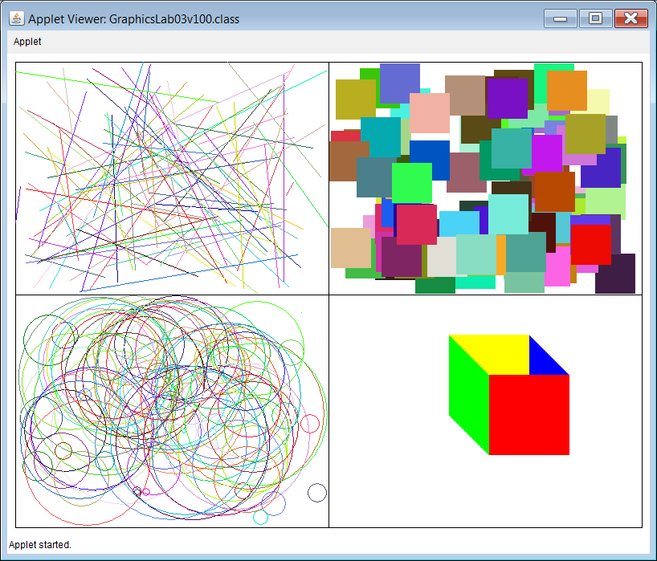

**110 Point Version**

For 110 points, you need to alter your program so that it uses **Math.random()** instead of the **nextInt** method of the **Random** class. The output should be the same as the 100 point version above.

NOTE: The 110 point version can only be done after the 100 point version is completed.